Preparing for Surgery

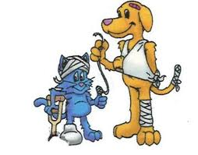

INSTRUCTIONS FOR ELECTIVE SURGERY:

HOME PREPARATION FOR SURGERY

- No food after 12:00 AM the night BEFORE surgery.
- Free-choice water should remain available at all times.
- Drop-off between 8:00-8:30 AM, morning of procedure.

WHEN PET IS ADMITTED

- Check in at the front desk
- Inform the office of any changes with pet since pervious visit.
- We ask that you provide the most current contact information, so that you can be informed of pets’ recovery.
- Any medication refills or requests is appreciated at this time
- Please ask any questions you might have, we will be happy to better inform you of your pets’ procedure.

Pets receive a pre-surgical physical examination to determine health status. You will also be offered pre-operative blood test these tests evaluate the health of your pet’s internal organs and may reveal problems not apparent by external exams. Pre-operative blood work is particularly recommended if your pet seems unhealthy in any way, and is required for all pets over seven years old.

You will be called prior to surgery if the exam or blood tests reveal any problems.

To see a step by step gallery of a patient getting prepped for surgery please check out our website at Hanahanvet.com and visit Curtis surgery day.



